**18.2.1**

What are you doing Sofi?

I'm making a new dishes

Oh, Can I try it?

Yes, Can you try it and tell me what you like and dislike?

I can do that

**Do you like bowls or plates?**

**I like bowls**...I like this. It's good

**Do you like the tomato sauce?**

**Yes, I like the red tomato sauce**, I like the pepper in it

Do you like the beef?

**I don't like the beef**

You don't like the beef. What's wrong with the beef?

It's tough

That's right. I need to cook it for 4 hours, not 2 hours. Do you like the sauce in the dish?

**I don't like the sauce in the dish**. This's a lot of sauce

**Do you like the white sauce?**

**Yes. I like the white sauce**. What do it?

Cream and garlic and cheese. A lot of cheese. **I like cheese**

I like cheese, but I really like this white sauce

Thank you

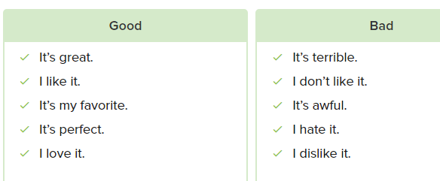

What does Danielle like?

* Bowls

What does Danielle think of tomato sauce?

* It’s good, and she likes the pepper

What do Danielle and Sofi think of the beef?

* Danielle dislikes it, and Sofi needs to cook it more

What does Danielle think about the white sauce?

* She likes the cheese in it

**Conversation**

I’m making a new dish. Do you like tomato and pasta?

I like tomatos, but I don’t like pasta

Ok, do you like red pepper and green pepper?

No, I hate all peppers

I see. Do you like cream and cheese?

I love cheese, but I really don’t like cream

Woa. My soup have all of those things in it. Try it! Do you like it?

I’m sorry. I don’t like the soup

Really, I’m sorry. Do you like Chinese food?

Yes, I do, I really like Chinese food

Huh, do you want to get Chinese food?

Sure! Let’s order it from the restaurant!

**Exercise**

Do you like white sauce or red sauce?

* I like white saucce

I like tomato soup. It’s delicious!

I think pizza is terrible. I really dislike it

Would you like some coffee?

* Sure. I love coffee

I reeally like this shirt, but I don’t like those pants

* Really? I like those pants. I think they’re cool

Do you like vegetable soup?

* Yes, I do. It’s really good

I love you T-shirt

* Thanks. It’s my favorite!

Do you like cream in your coffee?

* Yes, I do. I like a lot of cream.

18.2.2

Do you really like cooking?

Yes, I do

What do you like to do when you aren’t cooking?

Hmm.. **I read books in my apartment**

I like reading

**I live going to the movies**

**I go to the movie every week**. **Do you listen to music?**

**Yes, I listen to music a lot. I like Jazz**

I listen to a lot of music when I’m not at work. **Do you play sports: Foodball or goft or tennis?**

**No, I don’t play sports**. I’m not give that ball. **Do you play sports?**

**No, but I ride horses**

Woa. Do you have a horse?

No, my friend that a horse. We ride it on the weekend. **It’s my favourite hobby**

I think my favourite hobby, is cooking

What are Danielle and Sofi talking about?

* Their hobbies

Who likes reading?

* Sofi and Danielle

Who listen to music?

* Sofi and Danielle

What sports does Sofi play?

* She doesn’t play sports

Who rides horses?

* Only Danielle

What is Sofi’s favorite hobby?

* Making food